Currency Calc Pro: Smart Currency Conversion System

Currency Calc Pro Innovations

Android Application Development

Katrina C. Ramonolos – Project Manager
Verna A. Geñoso – Lead Developer
Verna A. Geñoso – UI/UX Designer
Ivy P. Danggaon – Research / QA Tester

ESMADE WHELSTER R.

December 19, 2025

EXECUTIVE SUMMARY

Currency Calc Pro is an Android-based currency conversion application designed to provide fast, accurate, and convenient foreign exchange calculations. The system enables users to convert monetary values between different international currencies using updated exchange rates. Through a simple and intuitive interface, users can quickly perform conversions for travel, online transactions, academic purposes, and business use. The application aims to reduce calculation errors, save time, and improve accessibility to reliable currency information.

INTRODUCTION

With the growth of international travel, e-commerce, and online freelancing, the need for accurate currency conversion has become essential. Many individuals rely on manual computations or unreliable online sources, which may result in incorrect values. Currency Calc Pro was developed to offer a dependable and user-friendly mobile solution for currency conversion anytime and anywhere.

Statement of the Problem

- Manual currency conversion is time-consuming and prone to errors
- Limited access to reliable and updated exchange rates
- Existing applications are often complex or overloaded with ads
- Difficulty converting multiple currencies quickly

Project Objectives

- To develop an Android application for accurate currency conversion.
- To provide updated exchange rates for multiple currencies.
- To design a simple, user-friendly, and responsive interface.
- To assist users in making informed financial decisions.

Scope and Limitations

Scope:
- Currency selection and conversion
- Support for multiple international currencies
- Online exchange rate updates.
- Offline conversion of currency per country.

Limitations:
- Real-time updates of newest currency rates
- App configuration and system settings
- Less than 50 current countries are selected.
- Support basic calculations and not complex mathematical equations.

STARTUP CONCEPT

Value Proposition

Currency Calc Pro provides a fast, reliable, and easy-to-use currency conversion tool that helps users calculate foreign exchange values with confidence and accuracy.

Target Market / Users

- Students
- Travelers and tourists
- Online sellers and freelancers
- Business professionals

SWOT Analysis

Strengths:
- Simple and intuitive user interface
- Accurate and fast conversion results
- Lightweight Android application.

Weaknesses:
- Internet dependency for live updates
- Limited advanced financial tools.

Opportunities:
- Integration with cryptocurrency conversion
- Expansion to iOS platform
- Offline enhancements and historical rate tracking.

Threats:
- Competition from existing currency converter apps
- API service downtime or rate limits.

SYSTEM OVERVIEW

System Description

Currency Calc Pro is a mobile-based system that allows users to input an amount, select source and target currencies, and instantly view the converted value based on current exchange rates retrieved from an online API.

Key Features
- Multi-currency support
- Real-time exchange rate updates
- Offline mode using cached rates
- Favorite currency selection
- Clean and responsive user interface

System Requirements

Software: Android OS, Java/Kotlin, Exchange Rate API
Hardware: Android smartphone.

SYSTEM DESIGN

Use Case Diagram

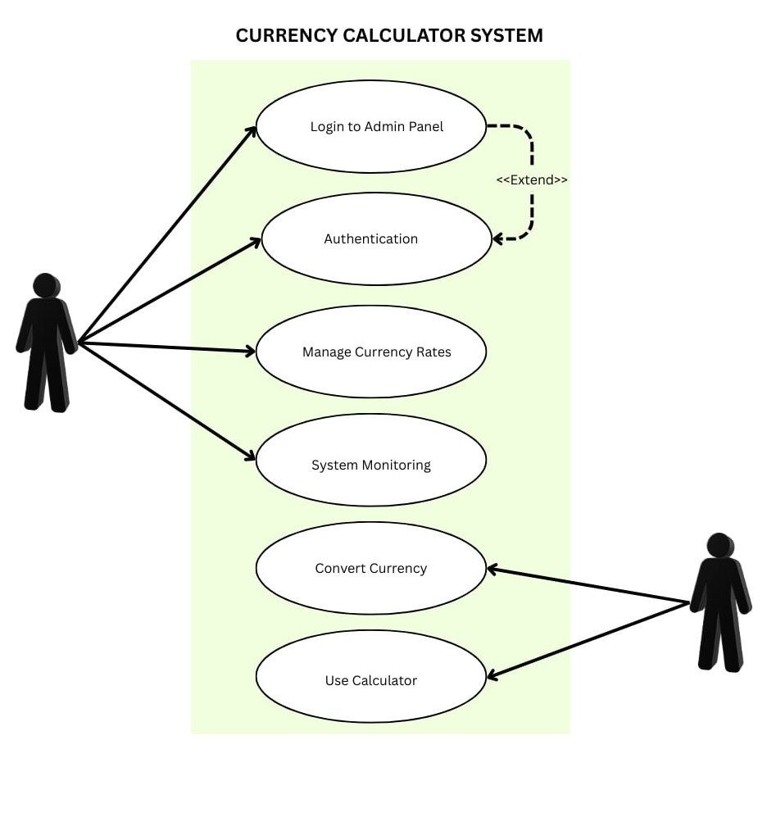

Context Diagram
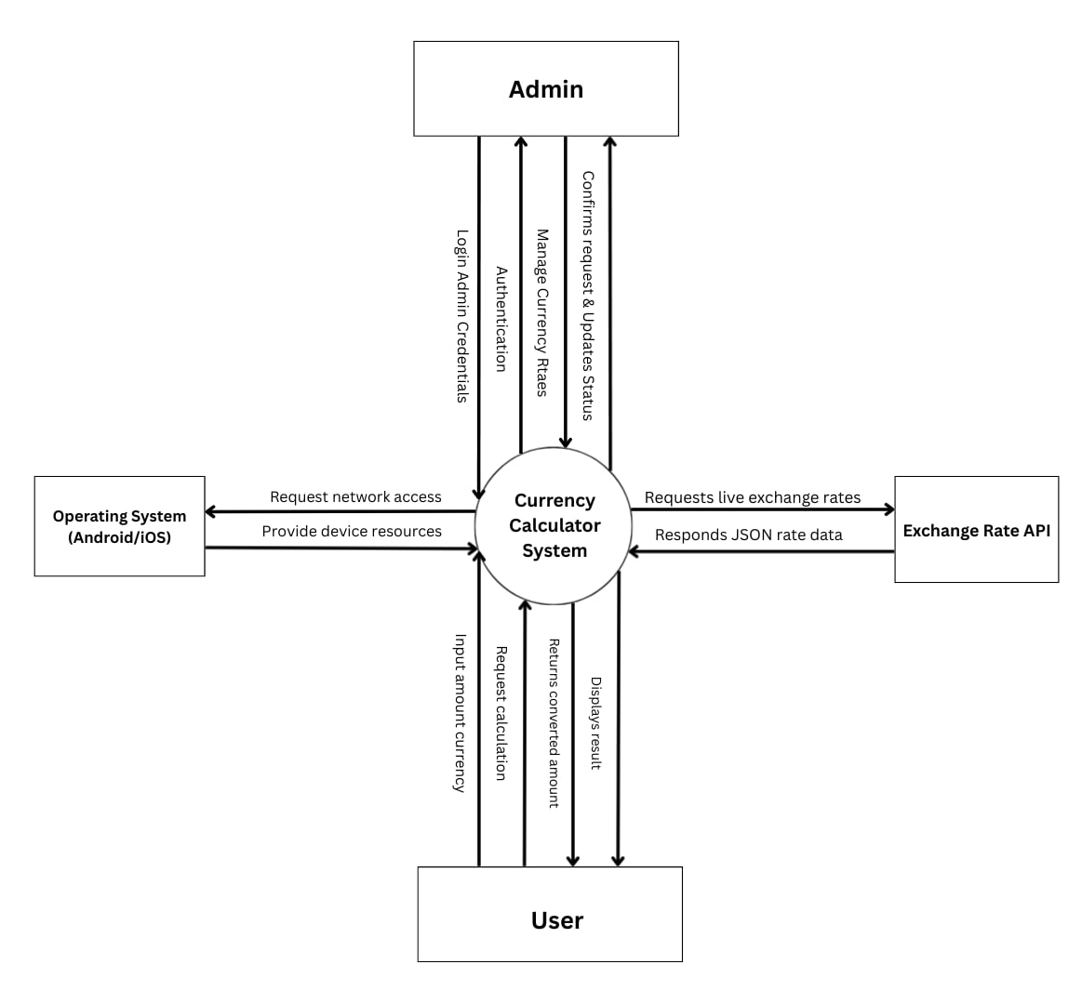

Data Flow Diagram

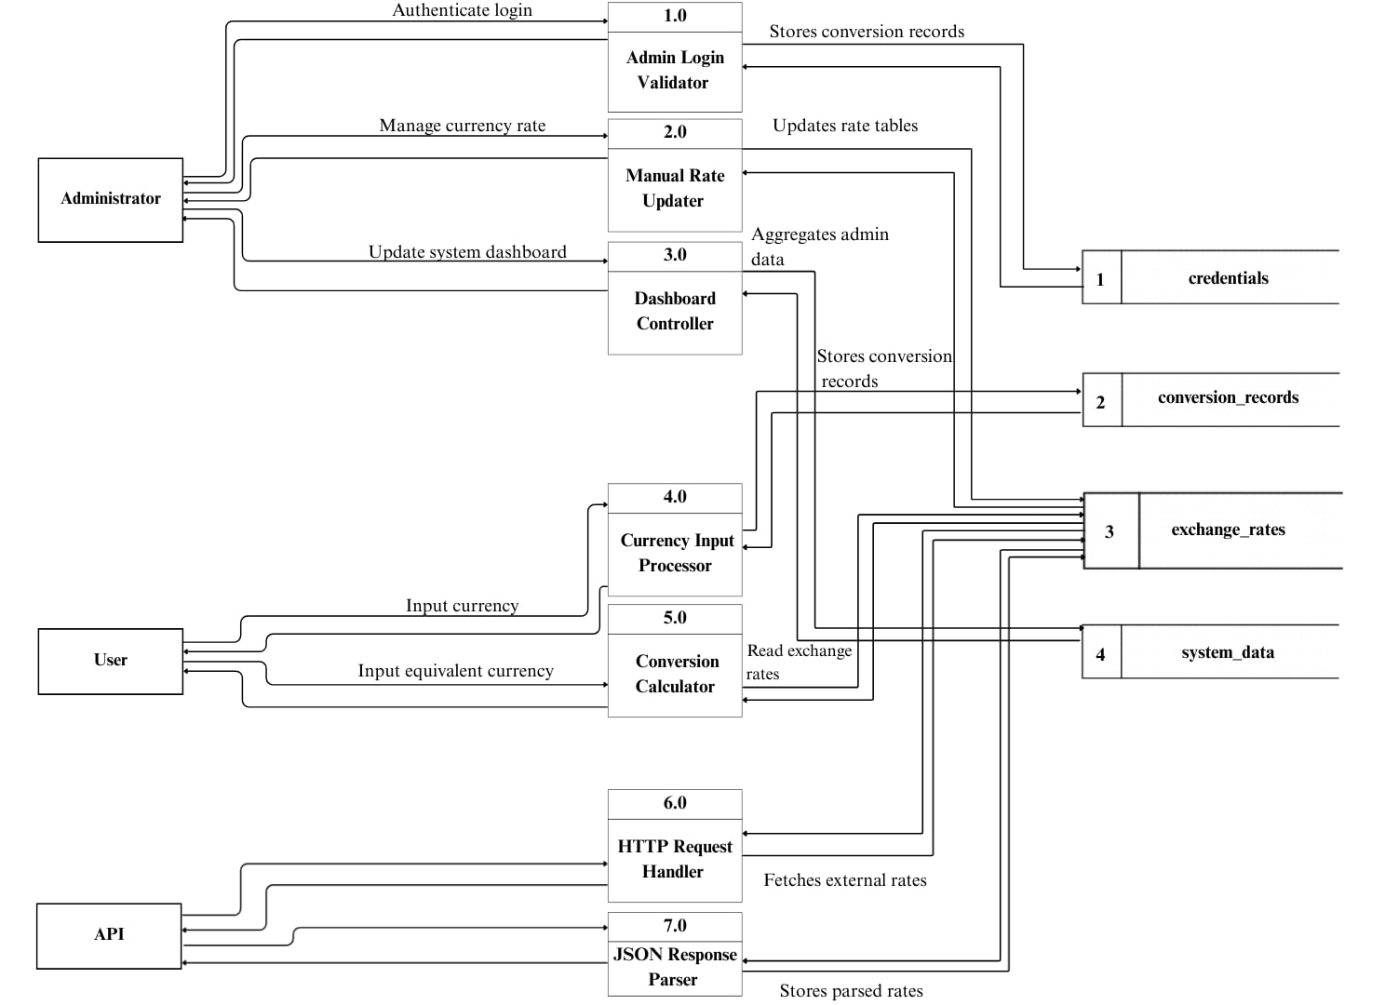

Entity Relationship Diagram

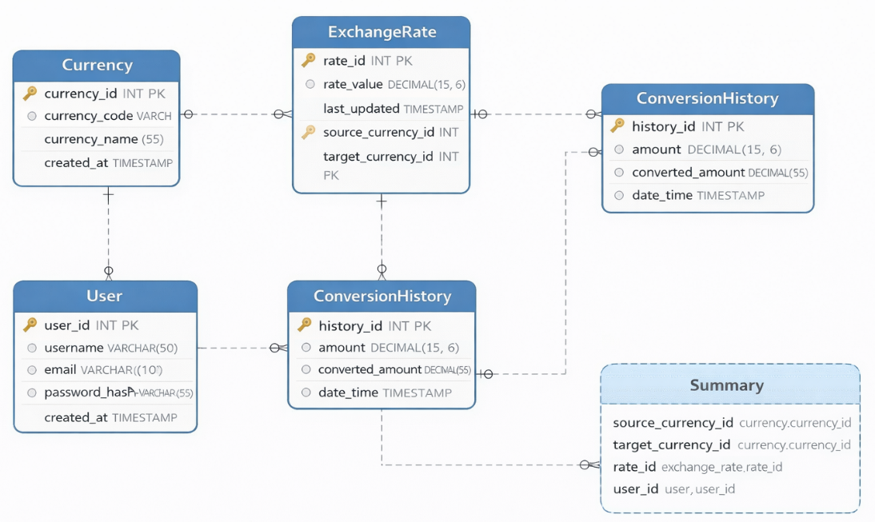

System Architecture

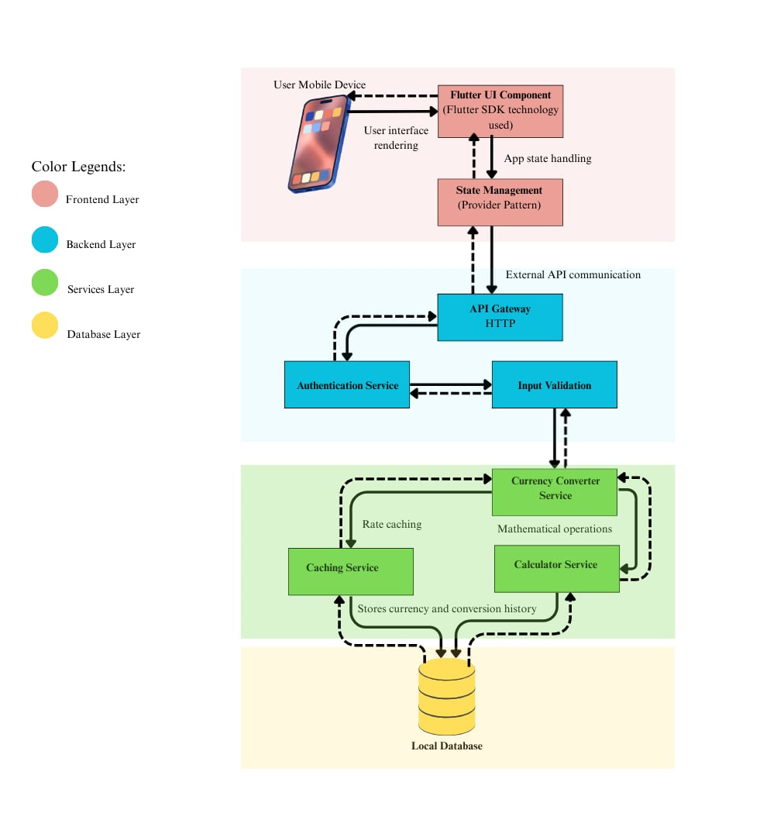

UI/UX DESIGN

Wireframes / Mockups

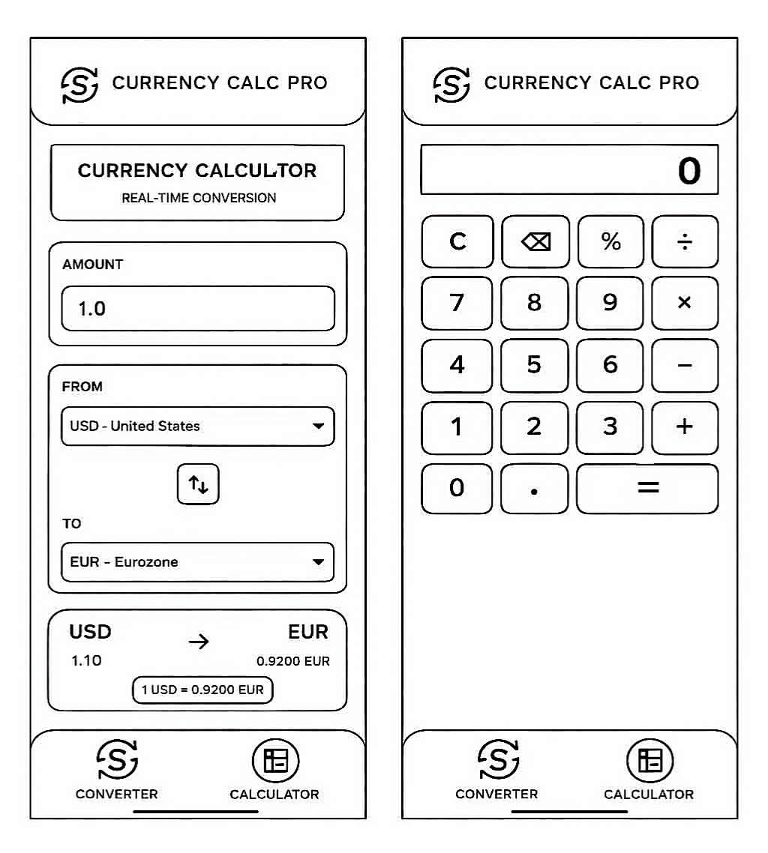
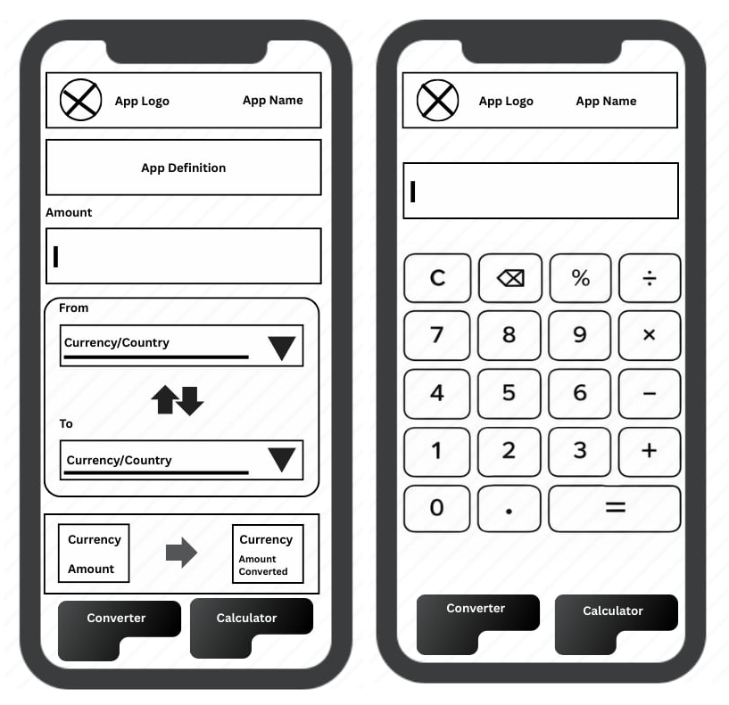

User Flow

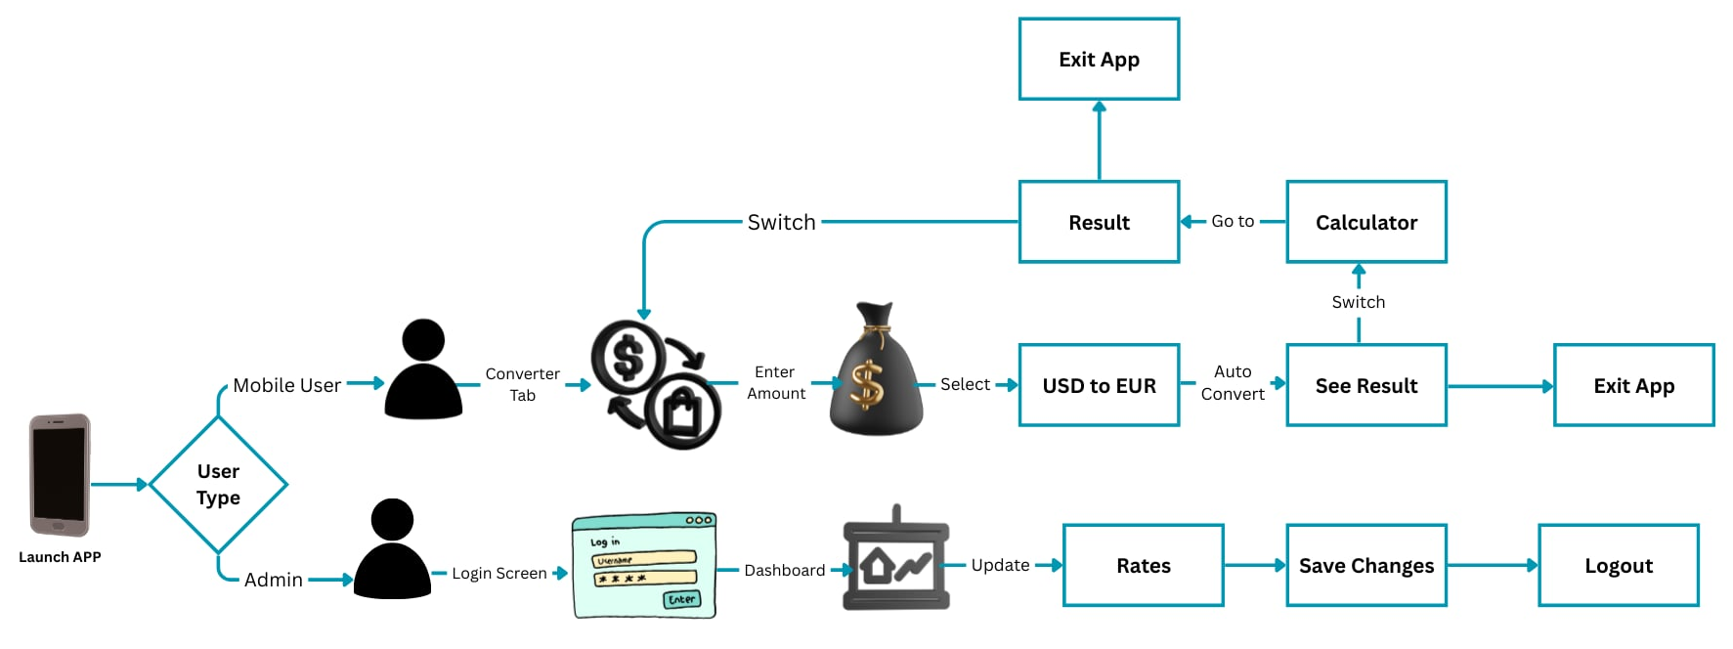

IMPLEMENTATION

Development Tools
- Frontend: XML (Android UI)
- Backend Logic: Kotlin / Java
- API: Exchange Rate API
- Design: Figma

Modules and Functions
- Currency selection module
- Conversion calculation module
- Exchange rate update module
- Offline data storage module

FUTURE ENHANCEMENTS

- Cryptocurrency conversion support
- Historical exchange rate charts
- iOS version development
- Dark mode and accessibility improvements

CONCLUSION

Currency Calc Pro demonstrates the successful development of a practical Android application that addresses common challenges in currency conversion. By providing accurate calculations, a simple interface, and reliable exchange rate data, the application proves to be a valuable tool for everyday users and professionals alike.

REFERENCES
Shaikh, A., Momin, A., Jadhav, M., & Patil, R. (2021). Currency converter system. International Journal of Advanced Research in Computer and Communication Engineering, 10(5), 15–19.
https://ijarcce.com/papers/currency-converter-system/
Geddam, R., Kumar, P., Reddy, S., & Kumar, M. (2021). Android application for currency conversion. International Research Journal of Engineering and Technology (IRJET), 8(7), 3081–3084.
https://www.irjet.net/archives/V8/i7/IRJET-V8I7597.pdf
Android Developers. (2024). Android application architecture guide.
https://developer.android.com/guide
ExchangeRate.host. (2024). Exchange rate API documentation.
https://exchangerate.host/documentation
ExchangeRate-API. (2024). Currency exchange rate API documentation.
https://www.exchangerate-api.com/docs/overview
Posadskiy, A. (2023). Currency converter library for Java and Android (Version 1.2) [Software]. GitHub.
https://github.com/posadskiy/currency-converter
DonGuillotine. (2022). Android currency converter application [Source code]. GitHub.
https://github.com/DonGuillotine/android-currency-converter

APPENDICES

